Pentagonal Bipyramid

Definition
# Source: AI Source: Provided by: [Data Path: Persons Table -> ID Column: 1, Name_En Column: Motasem Essam] -> From: [ChatGPT] on [7/25/2026]
A Pentagonal Bipyramid is a three-dimensional polyhedron formed by joining two pentagonal pyramids at their congruent pentagonal bases. The shared pentagonal base becomes an internal face, while the two pyramids' triangular lateral faces form the exterior surface.
It consists of:
- Two apexes positioned on opposite sides of a common pentagonal base.
- Five vertices forming the shared pentagonal base.
- Ten triangular faces surrounding the solid.
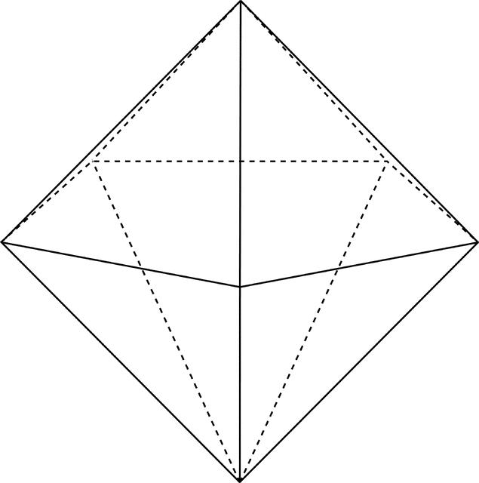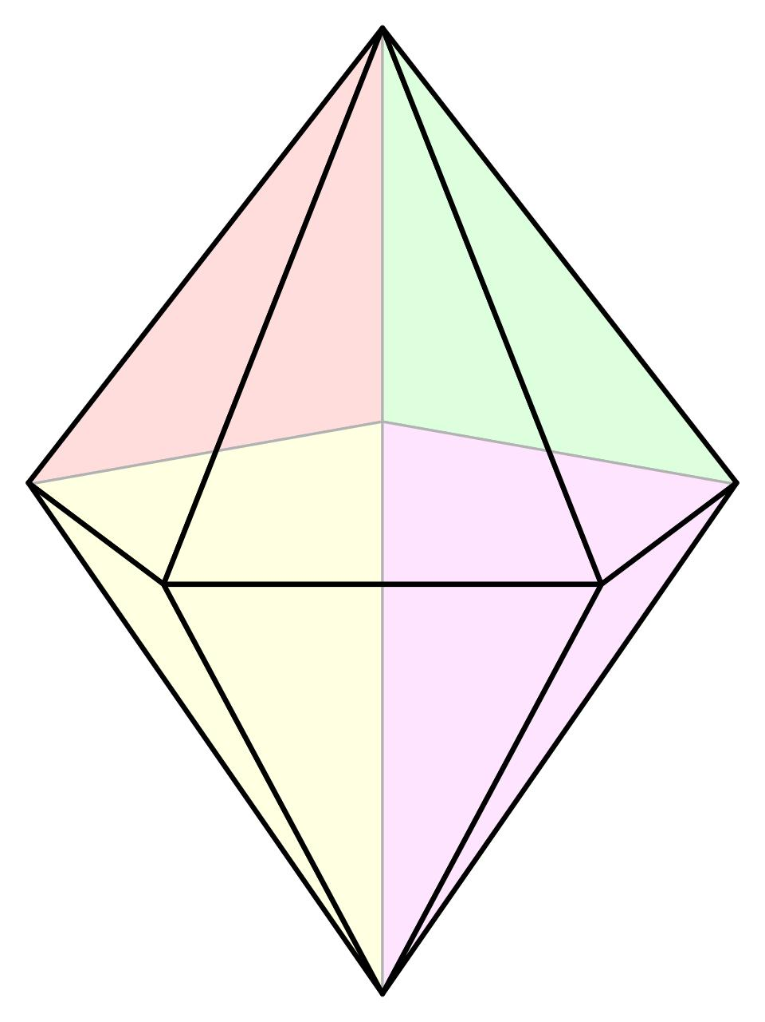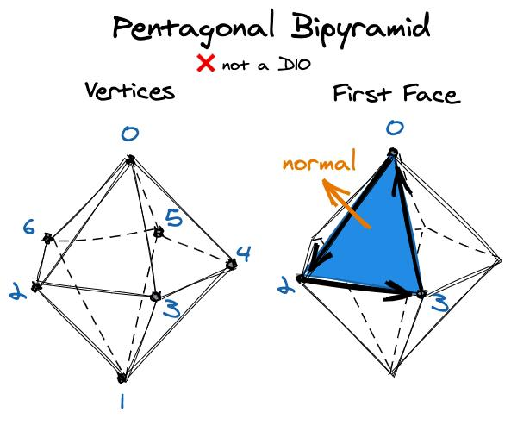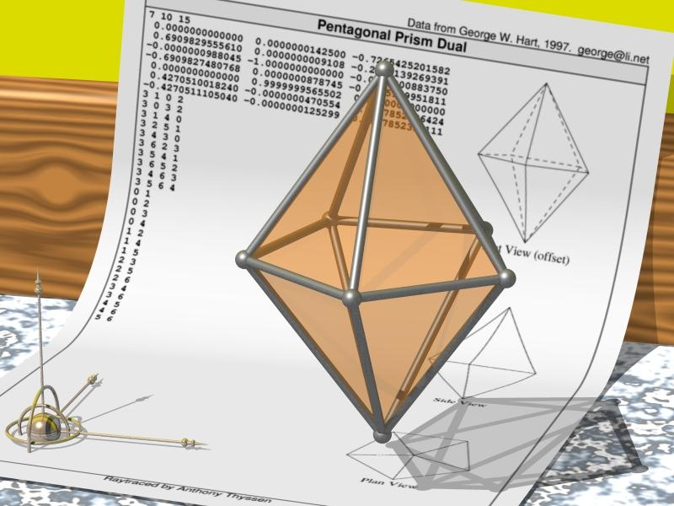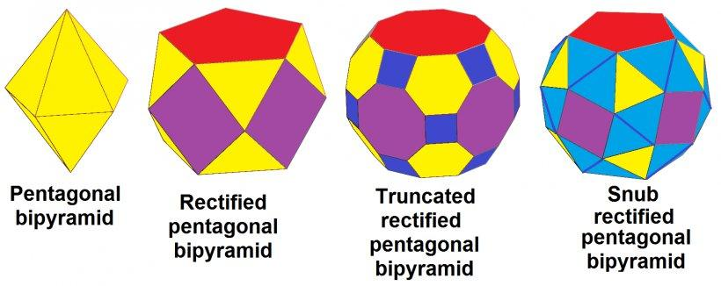

Simple Definition
# Source: AI Source: Provided by: [Data Path: Persons Table -> ID Column: 1, Name_En Column: Motasem Essam] -> From: [ChatGPT] on [7/25/2026]
A pentagonal bipyramid is a solid made by joining two pentagonal pyramids base-to-base, creating a polyhedron with 10 triangular faces, 15 edges, and 7 vertices.

Geometric Structure
# Source: AI Source: Provided by: [Data Path: Persons Table -> ID Column: 1, Name_En Column: Motasem Essam] -> From: [ChatGPT] on [7/25/2026]
The pentagonal bipyramid has three main structural components:
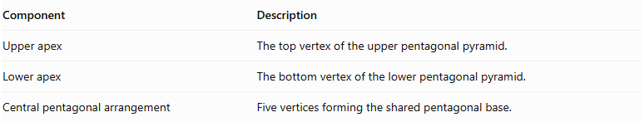
Component | Description
Upper apex | The top vertex of the upper pentagonal pyramid.
Lower apex | The bottom vertex of the lower pentagonal pyramid.
Central pentagonal arrangement | Five vertices forming the shared pentagonal base.
The two apexes are connected to all five vertices of the central pentagon.

Face Structure
# Source: AI Source: Provided by: [Data Path: Persons Table -> ID Column: 1, Name_En Column: Motasem Essam] -> From: [ChatGPT] on [7/25/2026]
A pentagonal bipyramid has 10 external triangular faces.
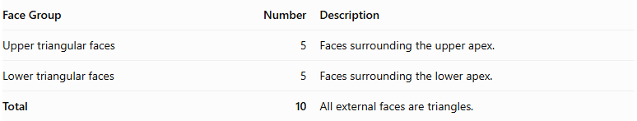
Face Group | Number | Description
Upper triangular faces | 5 | Faces surrounding the upper apex.
Lower triangular faces | 5 | Faces surrounding the lower apex.
Total | 10 | All external faces are triangles.
The common pentagonal base is internal, so it is not counted as an external face.

Edge Structure
# Source: AI Source: Provided by: [Data Path: Persons Table -> ID Column: 1, Name_En Column: Motasem Essam] -> From: [ChatGPT] on [7/25/2026]
The solid has 15 edges, divided into three groups:
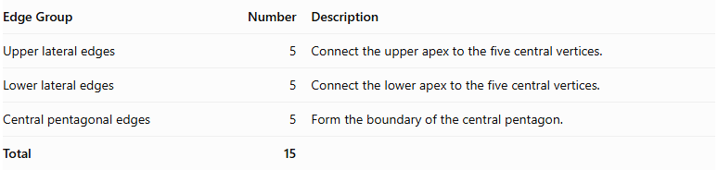
Edge Group | Number | Description
Upper lateral edges | 5 | Connect the upper apex to the five central vertices.
Lower lateral edges | 5 | Connect the lower apex to the five central vertices.
Central pentagonal edges | 5 | Form the boundary of the central pentagon.
Total | 15

Vertex Structure
# Source: AI Source: Provided by: [Data Path: Persons Table -> ID Column: 1, Name_En Column: Motasem Essam] -> From: [ChatGPT] on [7/25/2026]
A pentagonal bipyramid has 7 vertices.
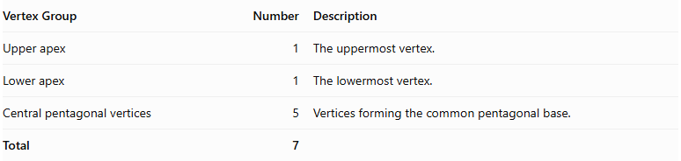
Vertex Group | Number | Description
Upper apex | 1 | The uppermost vertex.
Lower apex | 1 | The lowermost vertex.
Central pentagonal vertices | 5 | Vertices forming the common pentagonal base.
Total | 7

Mathematical Properties
# Source: AI Source: Provided by: [Data Path: Persons Table -> ID Column: 1, Name_En Column: Motasem Essam] -> From: [ChatGPT] on [7/25/2026]
For a pentagonal bipyramid:
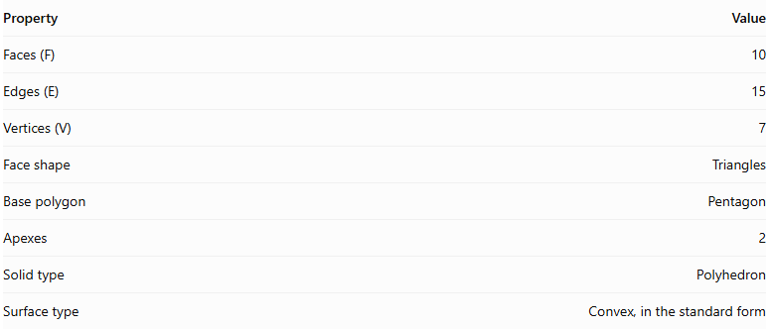
Property | Value
Faces (F) | 10
Edges (E) | 15
Vertices (V) | 7
Face shape | Triangles
Base polygon | Pentagon
Apexes | 2
Solid type | Polyhedron
Surface type | Convex, in the standard form
It satisfies Euler's polyhedron formula:
$$V-E+F=2$$
$$7-15+10=2$$

Face Incidence
# Source: AI Source: Provided by: [Data Path: Persons Table -> ID Column: 1, Name_En Column: Motasem Essam] -> From: [ChatGPT] on [7/25/2026]
In the standard pentagonal bipyramid:
- Each apex is shared by 5 triangular faces.
- Each central pentagonal vertex is shared by 4 triangular faces.

Surface Area and Volume

Surface Area
# Source: AI Source: Provided by: [Data Path: Persons Table -> ID Column: 1, Name_En Column: Motasem Essam] -> From: [ChatGPT] on [7/25/2026]
The total surface area is the sum of the areas of the ten external triangular faces.
For a symmetric pentagonal bipyramid with a regular pentagonal base:
$$SA=5A_{u}+5A_{l}$$
Where:
- $A_{u}$ = area of one upper triangular face.
- $A_{l}$ = area of one lower triangular face.
If the upper and lower pyramids are congruent:
$$SA=10A_{t}$$
Where $A_{t}$ is the area of one triangular face.
For a regular pentagonal bipyramid with equal lateral face geometry, if each triangular face has base side $s$ and slant height $l$:
$$SA=10(\frac{1}{2}sl)$$
$$\boxed{SA=5sl}$$

Volume
# Source: AI Source: Provided by: [Data Path: Persons Table -> ID Column: 1, Name_En Column: Motasem Essam] -> From: [ChatGPT] on [7/25/2026]
The volume is the sum of the volumes of the two pentagonal pyramids.
$$V=\frac{1}{3}{Bh}_{u}+\frac{1}{3}{Bh}_{l}$$
Therefore:
$$\boxed{V=\frac{1}{3}B(h_{u}+h_{l})}$$
Where:
- $B$ = area of the common pentagonal base.
- $h_{u}$ = height of the upper pyramid.
- $h_{l}$ = height of the lower pyramid.
For a regular pentagonal base with side length $s$:
$$B=\frac{1}{4}\sqrt{5(5+2\sqrt{5})},s^{2}$$
Thus:
$$\boxed{V=\frac{\sqrt{5(5+2\sqrt{5})}}{12}s^{2}(h_{u}+h_{l})}$$

Symmetry
# Source: AI Source: Provided by: [Data Path: Persons Table -> ID Column: 1, Name_En Column: Motasem Essam] -> From: [ChatGPT] on [7/25/2026]
A regular pentagonal bipyramid with congruent upper and lower pyramids has the following symmetries:
- Fivefold rotational symmetry: Rotation by ${72}^{∘}$ around the central axis maps the solid onto itself.
- Vertical reflection planes: Five planes pass through the central axis and bisect the pentagonal arrangement.
- Horizontal reflection plane: The central pentagonal plane reflects the upper half onto the lower half.
- Central inversion symmetry: Each point has a corresponding opposite point through the solid's center.

Relationship to Other Solids
# Source: AI Source: Provided by: [Data Path: Persons Table -> ID Column: 1, Name_En Column: Motasem Essam] -> From: [ChatGPT] on [7/25/2026]
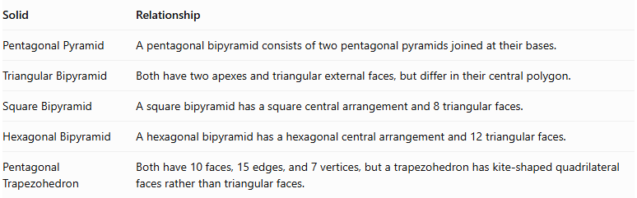
Solid | Relationship
Pentagonal Pyramid | A pentagonal bipyramid consists of two pentagonal pyramids joined at their bases.
Triangular Bipyramid | Both have two apexes and triangular external faces, but differ in their central polygon.
Square Bipyramid | A square bipyramid has a square central arrangement and 8 triangular faces.
Hexagonal Bipyramid | A hexagonal bipyramid has a hexagonal central arrangement and 12 triangular faces.
Pentagonal Trapezohedron | Both have 10 faces, 15 edges, and 7 vertices, but a trapezohedron has kite-shaped quadrilateral faces rather than triangular faces.

Worked Examples

Example 1: Calculate the Number of Faces, Edges, and Vertices
# Source: AI Source: Provided by: [Data Path: Persons Table -> ID Column: 1, Name_En Column: Motasem Essam] -> From: [ChatGPT] on [7/25/2026]
Given: A pentagonal bipyramid has a pentagonal central arrangement.
For an $n$-gonal bipyramid:
$$F=2n, E=3n, V=n+2$$
Since $n=5$:
$$F=2(5)=10$$
$$E=3(5)=15$$
$$V=5+2=7$$
Answer:
- Faces = 10
- Edges = 15
- Vertices = 7

Example 2: Calculate the Volume
# Source: AI Source: Provided by: [Data Path: Persons Table -> ID Column: 1, Name_En Column: Motasem Essam] -> From: [ChatGPT] on [7/25/2026]
Given:
- Area of the pentagonal base: $B=50{ cm}^{2}$
- Upper pyramid height: $h_{u}=8 cm$
- Lower pyramid height: $h_{l}=7 cm$
Using:
$$V=\frac{1}{3}B(h_{u}+h_{l})$$
Substitute:
$$V=\frac{1}{3}(50)(8+7)$$
$$V=\frac{750}{3}$$
$$\boxed{V=250{ cm}^{3}}$$

Constructing Pentagonal Bipyramid in Solid Geometry

Geometric Instruments Used
# Source: AI Source: Provided by: [Data Path: Persons Table -> ID Column: 1, Name_En Column: Motasem Essam] -> From: [ChatGPT] on [7/25/2026]
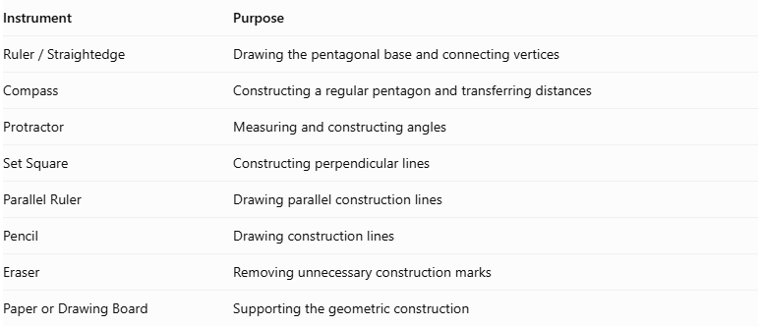
Instrument | Purpose
$$Ruler/Straightedge$$ | Drawing the pentagonal base and connecting vertices
Compass | Constructing a regular pentagon and transferring distances
Protractor | Measuring and constructing angles
Set Square | Constructing perpendicular lines
Parallel Ruler | Drawing parallel construction lines
Pencil | Drawing construction lines
Eraser | Removing unnecessary construction marks
Paper or Drawing Board | Supporting the geometric construction

Instrument-Based Construction Procedures

Constructing the Equatorial Pentagon
# Source: AI Source: Provided by: [Data Path: Persons Table -> ID Column: 1, Name_En Column: Motasem Essam] -> From: [ChatGPT] on [7/25/2026]
- Determine the required dimensions of the pentagonal base.
- Use a ruler and compass to construct a regular pentagon, if a regular base is required.
- Alternatively, construct an irregular pentagon with the specified side lengths and angles.
- Mark the five vertices as $A$, $B$, $C$, $D$, and $E$.
- Draw the five equatorial edges:
- $AB$
- $BC$
- $CD$
- $DE$
- $EA$

Locating the Two Apices
# Source: AI Source: Provided by: [Data Path: Persons Table -> ID Column: 1, Name_En Column: Motasem Essam] -> From: [ChatGPT] on [7/25/2026]
- Determine the intended positions of the two apices.
- Mark the upper apex as $P$.
- Mark the lower apex as $Q$.
- Position the two apices on opposite sides of the equatorial plane.
- For a symmetric pentagonal bipyramid, position both apices at equal perpendicular distances from the equatorial plane.

Connecting the Upper Apex
# Source: AI Source: Provided by: [Data Path: Persons Table -> ID Column: 1, Name_En Column: Motasem Essam] -> From: [ChatGPT] on [7/25/2026]
- Connect the upper apex $P$ to vertex $A$.
- Connect $P$ to vertex $B$.
- Connect $P$ to vertex $C$.
- Connect $P$ to vertex $D$.
- Connect $P$ to vertex $E$.
These connections form five upper triangular faces:
- Triangle $PAB$
- Triangle $PBC$
- Triangle $PCD$
- Triangle $PDE$
- Triangle $PEA$

Connecting the Lower Apex
# Source: AI Source: Provided by: [Data Path: Persons Table -> ID Column: 1, Name_En Column: Motasem Essam] -> From: [ChatGPT] on [7/25/2026]
- Connect the lower apex $Q$ to vertex $A$.
- Connect $Q$ to vertex $B$.
- Connect $Q$ to vertex $C$.
- Connect $Q$ to vertex $D$.
- Connect $Q$ to vertex $E$.
These connections form five lower triangular faces:
- Triangle $QAB$
- Triangle $QBC$
- Triangle $QCD$
- Triangle $QDE$
- Triangle $QEA$

Completing the Pentagonal Bipyramid
# Source: AI Source: Provided by: [Data Path: Persons Table -> ID Column: 1, Name_En Column: Motasem Essam] -> From: [ChatGPT] on [7/25/2026]
- Draw all ten external triangular faces.
- Identify the visible and hidden edges.
- Use solid lines for visible edges.
- Use dashed lines for hidden edges when necessary.
- Verify that both pentagonal pyramids share the same equatorial pentagon.
- Ensure that the shared pentagonal base is internal rather than an external face.

Constructing a Regular Pentagonal Bipyramid
# Source: AI Source: Provided by: [Data Path: Persons Table -> ID Column: 1, Name_En Column: Motasem Essam] -> From: [ChatGPT] on [7/25/2026]
- Construct a regular pentagonal equatorial base with side length $a$.
- Determine the center of the pentagon using suitable geometric constructions.
- Construct a perpendicular line through the center of the pentagonal base.
- Position the upper and lower apices symmetrically on opposite sides of the equatorial plane.
- Select the required perpendicular height for both pyramidal portions.
- Connect each apex to all five pentagonal vertices.
- Verify that the ten lateral faces are congruent isosceles triangles.

Constructing a Pentagonal Bipyramid Using a Net
# Source: AI Source: Provided by: [Data Path: Persons Table -> ID Column: 1, Name_En Column: Motasem Essam] -> From: [ChatGPT] on [7/25/2026]
- Construct ten triangular faces.
- Arrange five triangles around the upper pyramidal portion.
- Arrange five triangles around the lower pyramidal portion.
- Ensure that the corresponding edges have matching lengths.
- Fold the triangles to form the two pentagonal pyramidal portions.
- Join the corresponding edges to complete the pentagonal bipyramid.

Key Points
# Source: AI Source: Provided by: [Data Path: Persons Table -> ID Column: 1, Name_En Column: Motasem Essam] -> From: [ChatGPT] on [7/25/2026]
- A pentagonal bipyramid is formed by joining two pentagonal pyramids at their bases.
- It has 10 external triangular faces.
- It has 15 edges.
- It has 7 vertices.
- Its common pentagonal base is internal and is not counted as an external face.
- Its volume is the sum of the volumes of the two pentagonal pyramids.
- A regular symmetric pentagonal bipyramid has fivefold rotational symmetry.

Conclusion
# Source: AI Source: Provided by: [Data Path: Persons Table -> ID Column: 1, Name_En Column: Motasem Essam] -> From: [ChatGPT] on [7/25/2026]
The Pentagonal Bipyramid is a polyhedron formed by combining two pentagonal pyramids around a shared pentagonal base. It belongs to the family of $n$-gonal bipyramids and has 10 triangular faces, 15 edges, and 7 vertices.
Its defining characteristic is the five-sided central arrangement connecting the upper and lower apexes.

